GENETIC PROGRAMMING TEST 2
Applying “Hamming Distance”

ELEMENTS THAT WILL CHANGE DURING TEST:

VARIABLES TECHNIQUES
Population size cut
Crossover number slipcut
Mutation (Standard) slipcutup
Mutate Number peal
Mutate Operation pealup
Initial Depth of Trees infaro
Length Max of Tree infaroup
outfaro
outfaroup

First we will test how well our GP model performs using the same variable inputs and just changing the techniques. This way we will be able to evaluate if the performance of our algorithm varies depending on the techniques.

SETUP:
The setup for the first test is the following:

Population size 1000
Crossover number 500
Mutation (Standard) 200
Mutate Number 0
Mutate Operation 0
Initial Depth of Trees 4
Length Max of Tree 20

So from a total of 100%, 50% will be crossovered and 20% of the crossover will be mutated.

Our objective function will be the distance between the output deck and the desired deck.
As the algorithm is stochastic each test will be run three times to get the average answer.
The metric to be used is “Hamming Distance”.

1. PART: TECHNIQUE ANALYISIS:
The experiments are going to be the same as in the first experiment but in this case using Hamming Distance. We have to analize the performance of the algorithm depending the techniques taking into account the next conditions: number of techniques, order of techniques, and used techniques.

FIRST TEST: (goal: test the performace of each technique separately)
For this experiment we will create as outputs different decks of cards (ordenations) using different techniques and we will see how well our algorithm performs. Example: we have a deck “A” and we will apply for example two cuts (cutting in position 13 and later in position 27 as an example), thus, we will get a deck “B”. Now we can see if or algorithm finds the proper way to reach from deck “A” to deck “B” which should be two cuts (with the numbers 13 and 27).

We will change the number of techniques but we will NOT take into account the order of techniques or used techniques, thus, we will just use one technique at a time.

Experiment Model:
We will just use one technique group at a time (on first experiment we proved that a technique has similar performance to the ones in its same group, this way we can optimize the time of the experiments) and we will increase the amount of that same technique, (the numbers on left of the techniques mean the number of times that we will apply that technique to the deck: 2, 4, 8, 16, 32 times to get the corresponding output, and then we will run our algorithm to see if with the input deck “A” it finds the output deck “B”).

We will analyze our output depending on two variables. Punctuation and number of generation we achieved each punctuation:

Experiment 1: cutting
cut | 2 | cut | 4 | cut | 8 | cut | 16 | cut | 32

Expected output: we expect the performance will always remain equal because no matter how many times you cut the deck, the deck order is never altered, just displaced from its original position.

Experiment 2: insertion
insert | 2 | insert | 4 | insert | 8 | insert | 16 | insert | 32

Expected output: taking into account that our model analizes literal positions, a slipcut or slipcutup is just displacing one card to a random place (like an insert on an array), thus, our model may possibly work a bit better than with “Sequence Metric”. We also expect that while increasing number of times we apply a technique, the model will have more difficulty finding a proper solution.

Experiment 3: inversion
invert | 2 | invert | 4 | invert | 8 | invert | 16 | invert | 32

Expected output: it is expected to have the same performance as “Sequence Metric” as both can find sequences (in this case in absolut position).

Experiment 4: intercalation
intercalation | 2 | intercalation | 4 | intercalation | 8 | intercalation | 16 | intercalation | 32

Expected output: this time we also expect a really bad performance as it seems that while doing several intercalations the deck has not any particular order. We could probably say that it is in a completely random ordenation. (Anyways, further analysis would be needed to confirm the hypothesis)

Hypothesis of outputs: on insertion (slipcut and slipcutup) and inversion (peal and pealup) techniques we expect a good performance. and each time we increase number of techniques will get harder., on cutting we expect always the same good performance as explained before, on intercalation (infaro, outfaro, infaroup and outfaroup) techniques we expect probably a bad performance as we assume that it is a chaotic ordenation and while increasing how many times we apply a technique we expect performance to get worse. So in summary, we expect quite similar results to the first experiment but probably with a better performance on insertions.

FIRST TEST CONLUSIONS:
N=2 Executions:

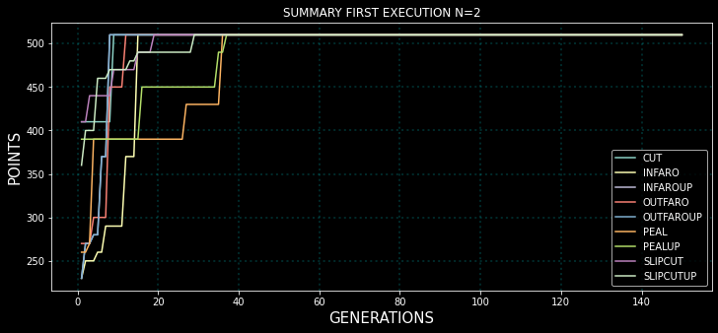
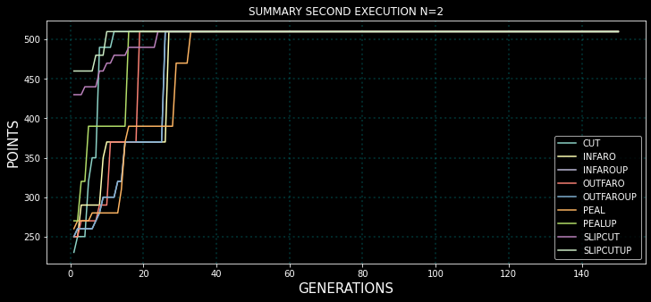
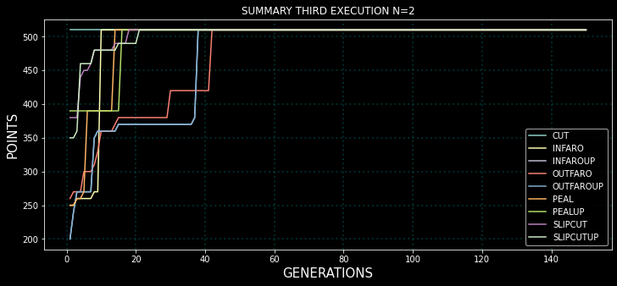

N=4 Executions:
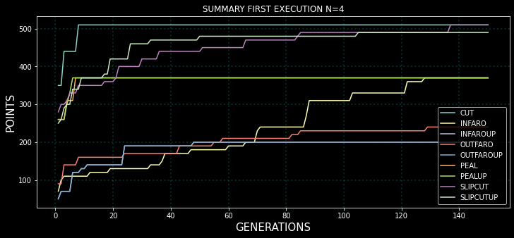
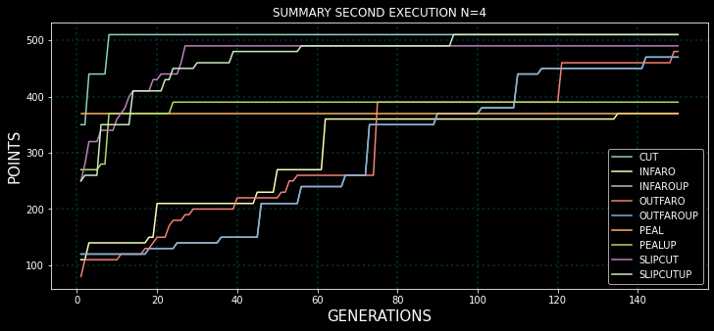

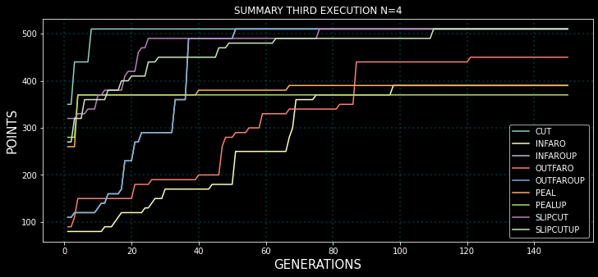
N=8 Executions:
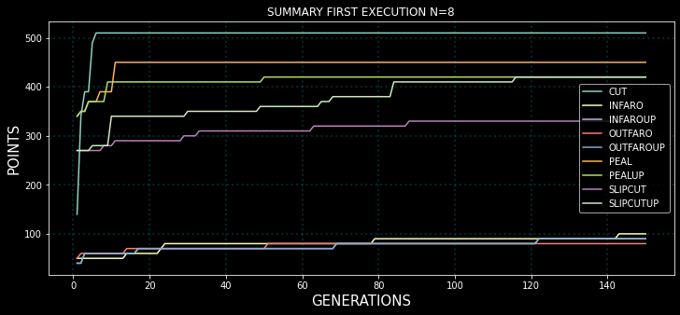
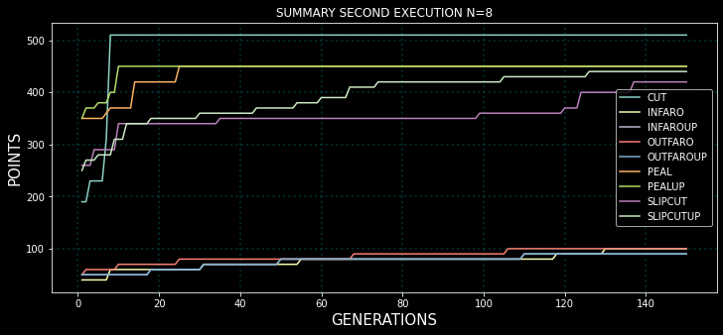
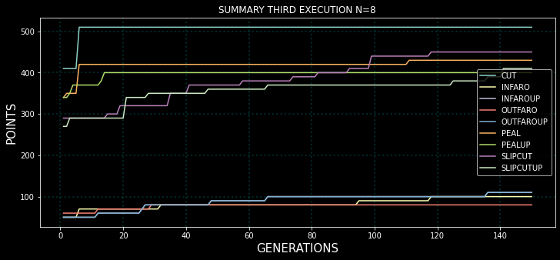

N=16 Executions:
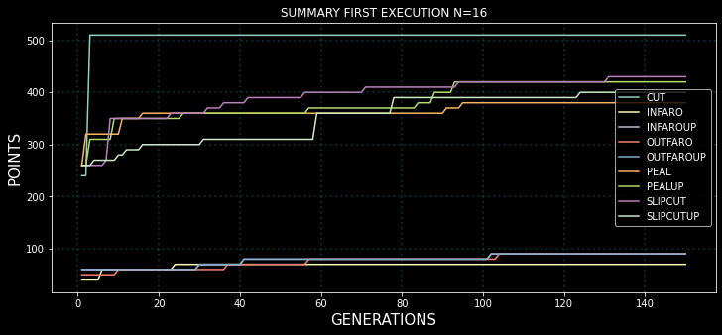

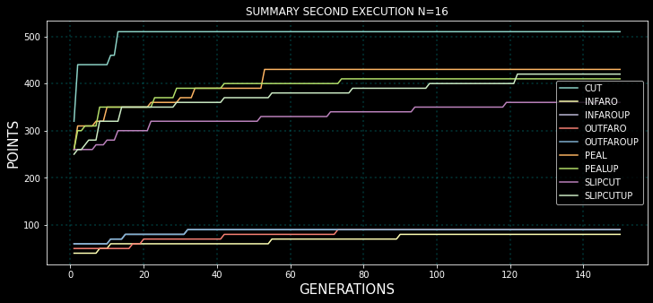

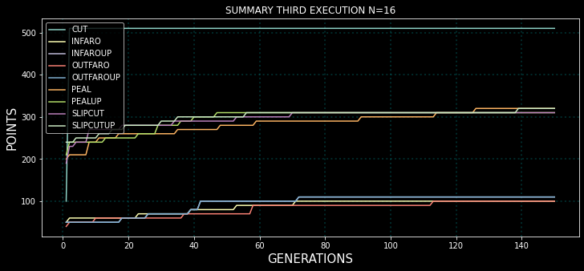
N=32 Executions:
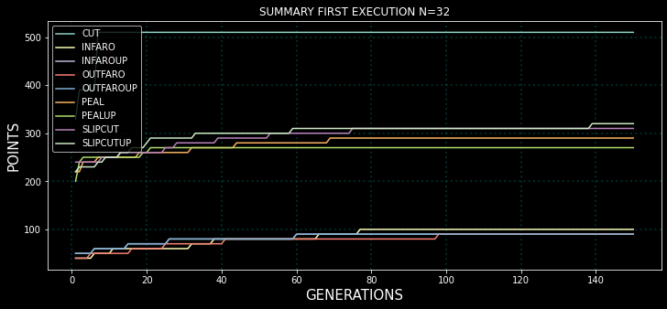

2. PART: GP EVOLUTION ANALYSIS:

FIRST TEST:
AFTER FINISHING 1.st PART.

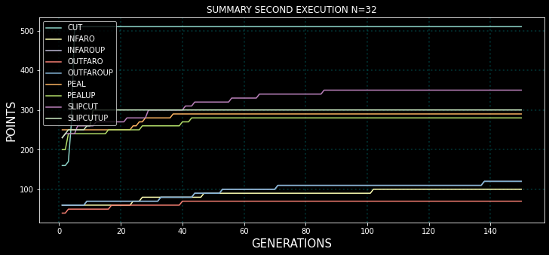
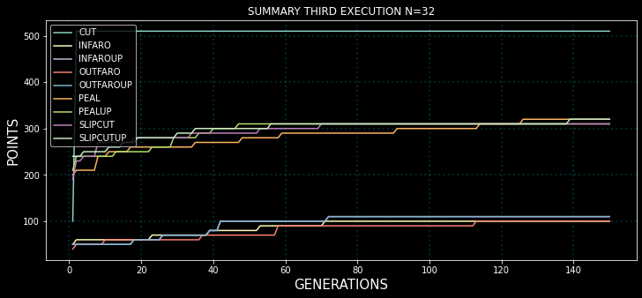
Insetion Inversion Conclusion:
Hypothesis:
on insertion (slipcut and slipcutup) and inversion (peal and pealup) techniques we expect a good performance. and each time we increase number of techniques will get harder.

Conclusion:
It is correct, as it has the same performance as seen in “sequence metric”.

Cutting Conclusion:
Hypothesis:
on cutting we expect always the same good performance as explained before,

Conclusion:
The hypothesis is perfect, if we analyze all the graphics no matter N=2,4,8,16,32 in the first generations the optimal solution is found. So in case of cutting the results are brilliant.

Intercalation Conclusion:
Hypothesis:
on intercalation (infaro, outfaro, infaroup and outfaroup) techniques we expect probably a bad performance as we assume that it is a chaotic ordenation and while increasing how many times we apply a technique we expect performance to get worse.

Conclusion:
It is again correct, the intercalation is a disaster with both metrics (“Sequence Metric” and “Hamming distance”).

General Conclusions of Test 1:
As we expected the performance is similar to sequence distance. The only thing that we expected was a bit of a better performance in insertions than in sequence distance. However, if we analyze it at any “N” the results are very similar, example:
Sequence Metric:
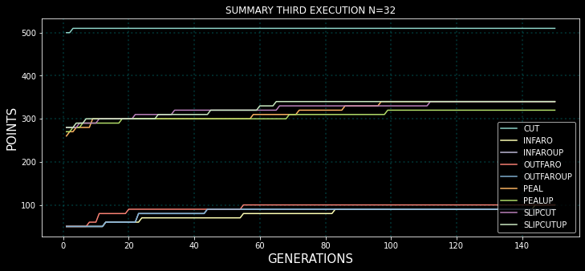

Hamming Distance:

SECOND TEST: (goal: test performance of combined techniques separately (used techniques))
The goal of the second test is to analyze the performance mixing different techniques at pairs. As we have 9 techniques (infaro, infaroup, outfaro, outfaroup, slipcut, slipcutup, peal, pealup, cut) that would mean testing 9^2 combinations (technically speaking (9^2)-9 as reapeated combinations have already been tested) which means testing around 81 combinations. Instead we are going to make group of similar techniques as the performace may be the same:

INTERCALATION TECHNIQUES:
-infaro
-infaroup
-outfaro
-outfaroup

INSERTION TECHNIQUES:
-slipcut
-slipcutup

INVERSION TECHNIQUES:
-peal
-pealup

CUTTING TECHNIQUES:
-cut

Now instead of having 9 techniques we have grouped them into 4 groups => (4^2)-4=12 combinations:

INTERCALATION | INSERTION
INTERCALATION | INVERSION
INTERCALATION | CUTTING
INSERTION | INTERCALATION
INSERTION | INVERSION
INSERTION | CUTTING
INVERSION | INTERCALATION
INVERSION | INSERTION
INVERSION | CUTTING
CUTTING | INTERCALATION
CUTTING | INSERTION
CUTTING | INVERSION

Note: we have assumed that techniques from the same group will have the same performance thanks to the first test.

Note: for intercalation we will use: infaro; for inversion we will use peal; for insertion we will use: slipcut; for cutting we will use: cut;

Experiment Model:

Based on our conclusions extracted from the previous experiment we will now assume the following:

-our model is perfect with cutting as it only displaces the deck no matter nomber of techniques.
-our model is good with pealing but will get harder with number of techniques.
-our model is good with insertion and will also get harder with number of techniques.
-our model is bad with intercalation but will get harder with number of techniques.

Experiment 1: INTERCALATION - INSERTION
INTER | 2 | INTER | 4 | INTER | 8 | INTER | 16 | INTER | 32
INSER | 2 | INSER | 4 | INSER | 8 | INSER | 16 | INSER | 32

Experiment 2: INTERCALATION - INVERSION
INTER | 2 | INTER | 4 | INTER | 8 | INTER | 16 | INTER | 32
INVER | 2 | INVER | 4 | INVER | 8 | INVER | 16 | INVER | 32

Experiment 3: INTERCALATION - CUTTING
INTER | 2 | INTER | 4 | INTER | 8 | INTER | 16 | INTER | 32
CUT | 2 | CUT | 4 | CUT | 8 | CUT | 16 | CUT | 32

Experiment 4: INSERTION - INTERCALATION
INSER | 2 | INSER | 4 | INSER | 8 | INSER | 16 | INSER | 32
INTER | 2 | INTER | 4 | INTER | 8 | INTER | 16 | INTER | 32

Experiment 5: INSERTION - INVERSION
INSER | 2 | INSER | 4 | INSER | 8 | INSER | 16 | INSER | 32
INVER | 2 | INVER | 4 | INVER | 8 | INVER | 16 | INVER | 32

Experiment 6: INSERTION - CUTTING
INSER | 2 | INSER | 4 | INSER | 8 | INSER | 16 | INSER | 32
CUT | 2 | CUT | 4 | CUT | 8 | CUT | 16 | CUT | 32

Experiment 7: INVERSION - INTERCALATION
INVER | 2 | INVER | 4 | INVER | 8 | INVER | 16 | INVER | 32
INTER | 2 | INTER | 4 | INTER | 8 | INTER | 16 | INTER | 32

Experiment 8: INVERSION - INSERTION
INVER | 2 | INVER | 4 | INVER | 8 | INVER | 16 | INVER | 32
INSER | 2 | INSER | 4 | INSER | 8 | INSER | 16 | INSER | 32

Experiment 9: INVERSION - CUTTING
INVER | 2 | INVER | 4 | INVER | 8 | INVER | 16 | INVER | 32
CUT | 2 | CUT | 4 | CUT | 8 | CUT | 16 | CUT | 32

Experiment 10: CUTTING - INTERCALATION
CUT | 2 | CUT | 4 | CUT | 8 | CUT | 16 | CUT | 32
INTER | 2 | INTER | 4 | INTER | 8 | INTER | 16 | INTER | 32

Experiment 11: CUTTING - INSERTION
CUT | 2 | CUT | 4 | CUT | 8 | CUT | 16 | CUT | 32
INSER | 2 | INSER | 4 | INSER | 8 | INSER | 16 | INSER | 32

Experiment 12: CUTTING - INVERSION
CUT | 2 | CUT | 4 | CUT | 8 | CUT | 16 | CUT | 32
INVER | 2 | INVER | 4 | INVER | 8 | INVER | 16 | INVER | 32

Hypothesis of outputs: inversion and insertion have similar performance, so, if we combine both we should get that inverting N times or inserting N times will have the same effect as combining both techniques N times. (example: 32 inversions or 32 intercalations should get same performance as 32 inversions and intercalations (16 inversions + 16 intercalations)).

So supposedly inversions and insertions will be in the same performace type.

Then we have intercalation, we expect its performace to be bad and later on even worse, so, if we mix it with inversion or insertion (which performance may be good and worsen with time) we will have something like between the bad performance of intercalation and the good performance of inversions and insertions.

So supposedly mixing inversions or insertions with intercalations will be better than just intercalation but worse than intesertions or inversions.

Finally, we have the cutting, we dont know how the cutting will affect the other two groups (insertions – inversions and intercalations).

SECOND TEST CONLUSIONS:
N=2 Executions:
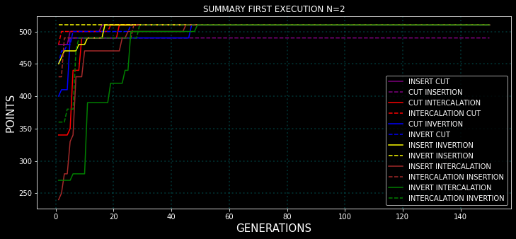
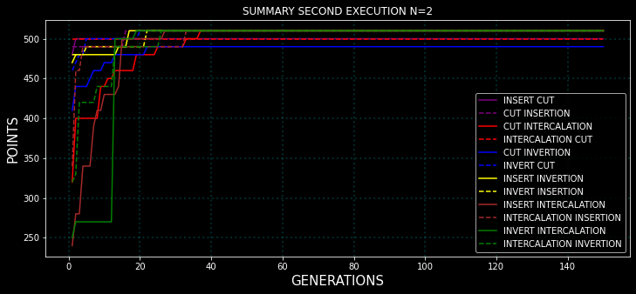
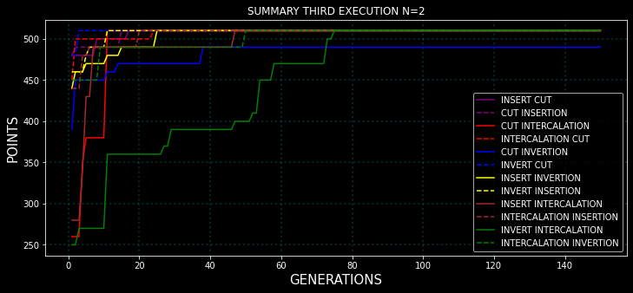
N=4 Executions:

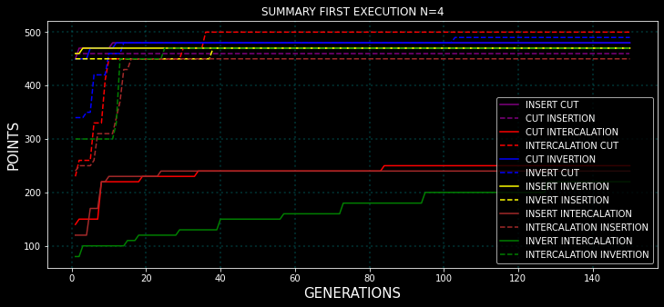
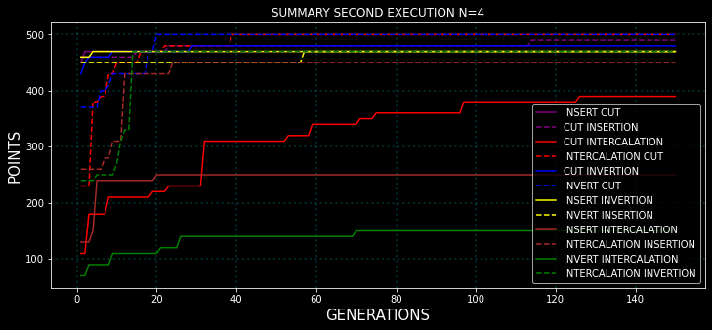
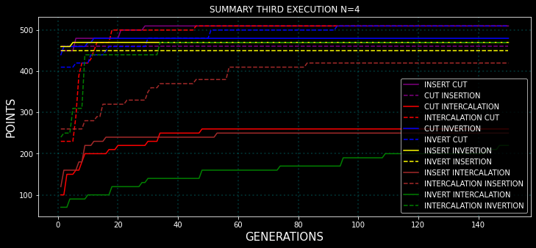
N=8 Executions:

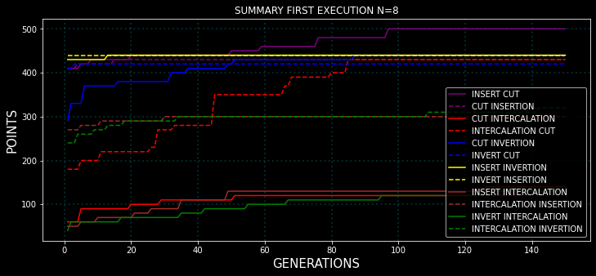
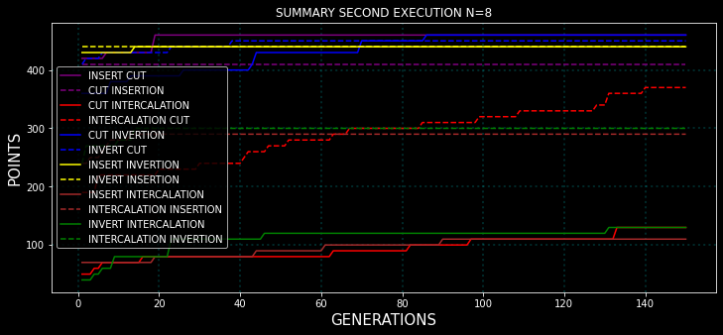
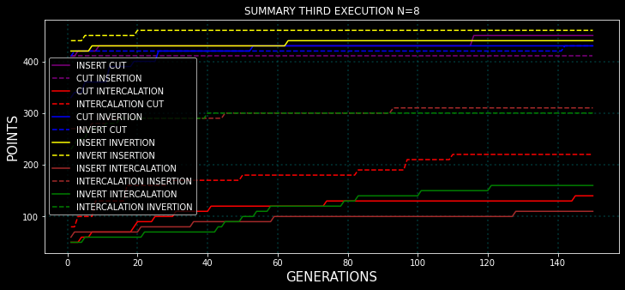
N=16 Executions:
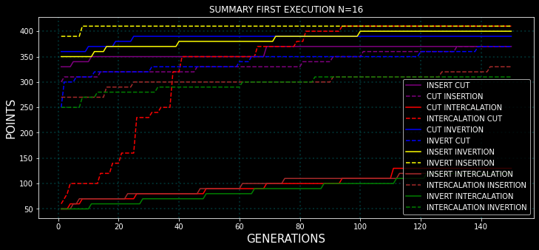
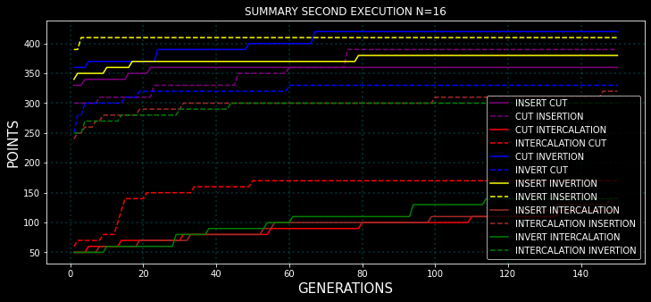
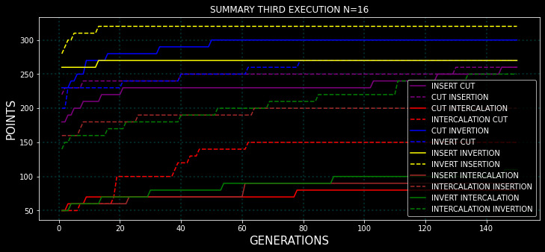
N=32 Executions:
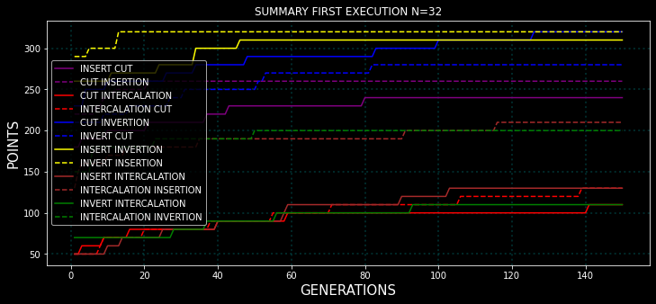
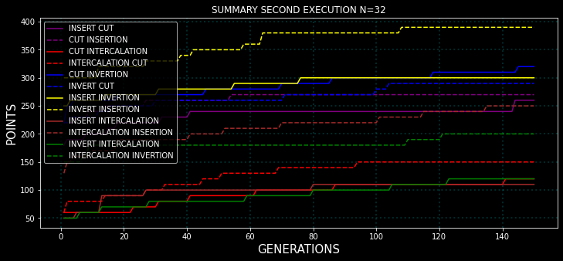
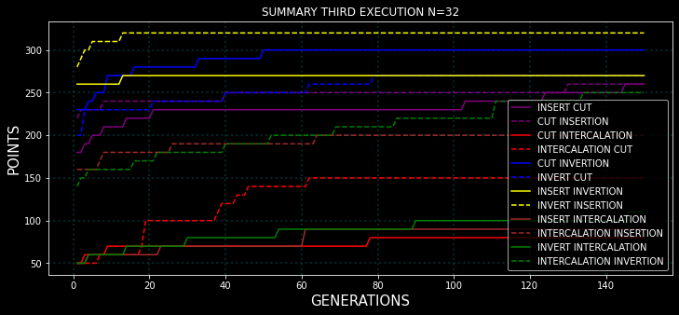
NOTE: We have three groups of performance: cutting / inversions and insertions / intercalations. Ordered from best to worst performance as we concluded earlier in test 1.

First Conclusion:
Hypothesis:
So inversions and insertions are in the same performace type, thus, if we combine them both we should get the same performace as having them separated.
example: 32 inversions or 32 intercalations should get same performance as 32 inversions and intercalations (16 inversions + 16 intercalations)

Conclusion:
It is correct, the performance in just insertions, or just inversions or insertions+inversions in both cases is around 320 points (generation 150 | N=32) . In conclusion {points(32 insertions)=points(32 inversions)=points(16 insertions+16 inversions) | points is the punctuation at generation 150}

Second Conclusion:
Hypothesis:
Then we have intercalation, we expect its performace to be bad and later on even worse, so, if we mix it with inversion or insertion (which have the same performace as stated before in test 1) we will have something like between the bad performance of intercalation and the good performance of inversions and insertions.

Conclusion:
It is again correct, if we take for example N=32 (Generation 150) we can see that intercalation scores around 100 points whereas insertion or inversion 300 points. If we see the points of intercalation-insertion, insertion-intercalation, intercalation-inversion or inversion-intercalation we can see that its around 200 which is the spected average.

Third Conclusion:
Hypothesis:
Finally, we have the cutting, we dont know how the cutting will affect the other two groups (insertions – inversions and intercalations).

Conclusion:
insertion-cut, cut-insertion is the best performance in N=32 (Generation 150) with 300 points
invertion-cut, cut-invertion is the middle performance in N=32 (Generation 150) with 150 points
intercalation-cut, cut-intercalation is the worst performance in N=32 (Generation 150) with 100 points.

Fourth Conclusion:
Hypothesis:
The order of operations will give similar results, example: insertion-inversion and inversion-insertion, intercalation-cut, cut-intercalation...

Conclusion:
The hypothesis is wrong.

(insert or invert) – intercalation: has the same increase rate as intercalation – (insert or invert), however, from generation 0, (insert or inver)-intercalation starts much further than intercalation-(insert or invert). The first starts from 150 points whereas the second one from 50 points.

Intercalation-cut: even if it starts in the same position in generation 0 as its opposite (cut-intercalation), the first gets around 150 points (N=32 generation 150) and the second at most 100 (N=32 generation 150).

rest of the cases: They start at around 50 points of difference eachone respect to its opposite and as the increase rate is equal, at the end (N=32 generation 150) they still remain with the same difference.

Lets analyze which technique combinations are better than their opposites to try to understand what is happening (lets suppose we are at N=32 and Generation 150):
Minimum Scores:
INSERT CUT: 250
INVERT CUT:300
INSERT INVERTION:300
INSERT INTERCALATION:100
INVERT INTERCALATION:130
CUT INTERCALATION:120
Maximum Scores: (Opposites)
CUT INSERTION: 275
CUT INVERTION:350
INVERT INSERTION:400
INTERCALATION INSERTION:250
INTERCALATION INVERTION:200
INTERCALATION CUT:150

We can clearly see that a pattern is repeating in the data: when intercalation goes first it performs better than going second, and when insertion goes first it performs better than when going first. Why may be this the case?

Intercalation Hypothesis:
We can see that in generation 0 actually the values are completely different, and then through generations the increase rate remains the same in both cases, thus, we can say that just while just generating the random trees it finds better solutions when intercalation goes as the first technique of the combination. Why? Ni puñetera idea.

Insertion Hypothesis:
Again we can see that in generation 0 actually the values are completely different, and then through generations the increase rate remains the same in both cases, thus, we can say that just while just generating the random trees it finds better solutions when insertion goes as the second technique of the combination. Why? Ni puñetera idea. Me va a estallar la cabeza.

General Conclusions of Test 2:
First, we can clearly see that combining insertions and inversions have the same performance of using just insertions or just inversions.

Second, while combining intercalation with insertions or inversions we can also see that as the performance of intercalation is bad and the performance of insertions and inversions is good, we get an average result that is an in-between performance.

Third, the cutting dunno.

Fourth, is quite interesting to see that the order of the techniques affects the performance. They have the same increase rate each technique group to their opposite techniques but some of them start from a higher point rate than the other, exactly:

-when intercalation goes first it performs better than going second.
-when insertion goes first it performs better than when going first.

Ni idea del porque todavia :(

